New Dis-Eur-Czech Republic-Moravia-Dolní Věstonice-Figurine-Mammoth-26,000 BP

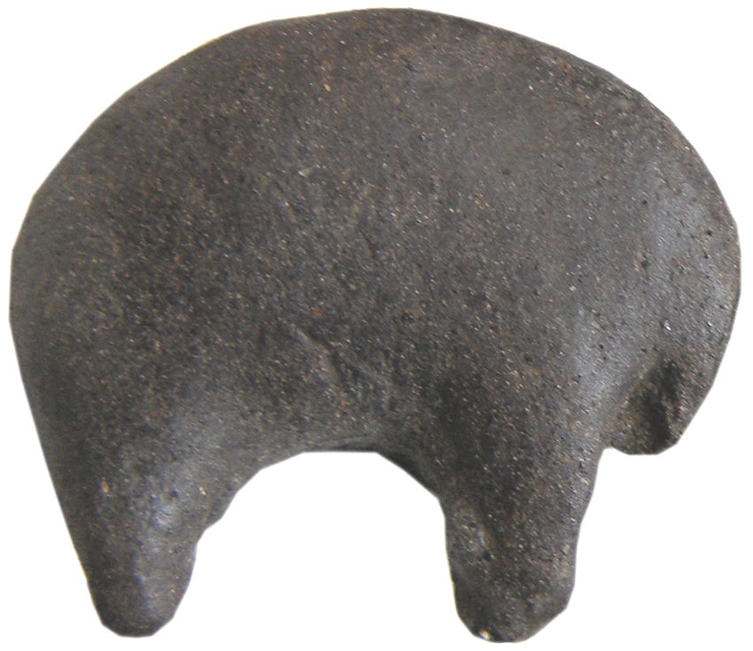

**Formal Label:** Czech Republic-Moravia-Dolní Věstonice-Figurine-Mammoth-26,000 BP

**Display Description:** This mammoth-ivory human head from Dolní Věstonice, Moravia, in the Czech Republic, was found on the hill of Pollau 549 m asl (1,801 ft), and was dated to approximately 26,000 BP. This site has been a source of artifacts of the Gravettian period (27,000-20,000 BP).

**Accession Number:**

**LC Classification:** GN772.22.C95

**Date or Time Horizon:** 26,000 BP C14

**Geographical Area:** Moravia in the Czech Republic, on the hill of Pollau.

**Map, GPS Coodinates**: 48.88822 16.64369, 40° 26' 46" N 79° 58' 56" W

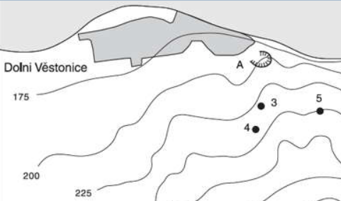 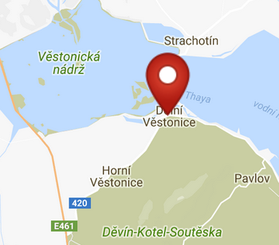 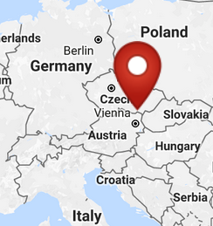

Fig. 2. Map of the location of Dolní Věstonice sites. Key: 3. Dolní Věstonice II; 4. Dolní Věstonice II-A; 5. Dolní Věstonice III; A. Dolní Věstonice source of stone. From Verpoorte 2000.

Figs. 3-4. Maps of the location of Dolní Věstonice from http://latitude.to/img/latitude-logo.svg.

**Cultural Affiliation:** Gravettian period

**Medium:** mammoth ivory

**Dimensions:   
Weight:**

**Provenance:**

**Condition: museum replica in resin.**

**Discussion:** Dolní Věstonice, Moravia in the Czech Republic, is on the hill of Pollau, 549 m (1,801 ft), and dates to the Gravettian period (26,000 BP). This abstract carving of a mammoth provides a glimpse into a developing aesthetic sense of geometric volumes that approach the animal as an artistic entity and not as a rationalistic entity that could be identified by its biology.

**References:**

Trinkaus, Erik and Jiri Svoboda (Eds.) 2005.*Early Modern Human Evolution in Central Europe: The People of Dolní Vestonice and Pavlov* (Human Evolution Series). New York: Oxford University Press.